**ASSIGNMENT NO.8**

Name: NEIL CARDOZ Roll no: 2307012079

Batch: AIML B1

Title: Calculator and Fibonnaci

1. Main.java

// Name : Neil Cardoz

// PRN : 2070126079

// Batch : AIML B1 23-27

public class Main {

public static void main(String[] args) {

// Creating an object of UserInput to display the menu

UserInput userInput = new UserInput();

// Creating an object of Calculator to perform operations

Calculator calc = new Calculator();

// Display the menu to the user

userInput.displayMenu();

}

}

2. UserInput.java

import java.util.Scanner;

class UserInput {

// Method to take two integer inputs from the user and return them as an array

int[] userInput() {

int[] numbers = new int[2];

Scanner scan = new Scanner(System.in);

System.out.println("Enter 1st Number:");

numbers[0] = scan.nextInt();

System.out.println("Enter 2nd Number:");

numbers[1] = scan.nextInt();

return numbers;

}

// Method to take an array of numbers input from the user

int[] userArrInput() {

int a;

Scanner scan = new Scanner(System.in);

System.out.println("Enter the length of the array:");

a = scan.nextInt();

int[] ar = new int[a];

for (int i = 1; i <= a; i++) {

System.out.println("Enter Number " + i + ":");

ar[i - 1] = scan.nextInt();

}

return ar;

}

// Method to display the menu and perform operations based on user choice

void displayMenu() {

Scanner scan = new Scanner(System.in);

System.out.println("\nSelect the operation:");

System.out.println("1. Addition");

System.out.println("2. Subtraction");

System.out.println("3. Multiplication");

System.out.println("4. Division");

System.out.println("5. Fibonacci Sequence");

System.out.println("6. Mean of an Array");

System.out.println("7. Variance of an Array");

int choice = scan.nextInt();

// Create a new Calculator object to perform operations

Calculator calc = new Calculator();

switch (choice) {

case 1:

int[] addNumbers = userInput();

System.out.println("Result of addition: " + calc.addition(addNumbers));

break;

case 2:

int[] subNumbers = userInput();

System.out.println("Result of subtraction: " + calc.subtraction(subNumbers));

break;

case 3:

int[] mulNumbers = userInput();

System.out.println("Result of multiplication: " + calc.multiplication(mulNumbers));

break;

case 4:

int[] divNumbers = userInput();

System.out.println("Result of division: " + calc.division(divNumbers));

break;

case 5:

System.out.println("Enter the number of Fibonacci terms you want:");

int n = scan.nextInt();

System.out.println("Fibonacci Sequence: ");

calc.fibonacci(n);

break;

case 6:

int[] arrForMean = userArrInput();

System.out.println("Mean of the array: " + calc.mean(arrForMean));

break;

case 7:

int[] arrForVariance = userArrInput();

System.out.println("Variance of the array: " + calc.variance(arrForVariance));

break;

default:

System.out.println("Invalid choice. Please select a valid operation.");

break;

}

}

}

3. Calculator.java

class Calculator {

// Method to perform addition

int addition(int[] numbers) {

return numbers[0] + numbers[1];

}

// Method to perform subtraction

int subtraction(int[] numbers) {

return numbers[0] - numbers[1];

}

// Method to perform multiplication

int multiplication(int[] numbers) {

return numbers[0] * numbers[1];

}

// Method to perform division

double division(int[] numbers) {

if (numbers[1] == 0) {

System.out.println("Error: Division by zero is not allowed.");

return 0;

}

return (double) numbers[0] / numbers[1];

}

// Method to calculate Fibonacci sequence up to nth term

void fibonacci(int n) {

int first = 0, second = 1;

// Print the Fibonacci sequence up to n terms

System.out.print(first + " " + second + " ");

for (int i = 3; i <= n; i++) {

int nextTerm = first + second;

System.out.print(nextTerm + " ");

first = second;

second = nextTerm;

}

System.out.println();

}

// Method to calculate the mean of an array

double mean(int[] numbers) {

double sum = 0;

for (int num : numbers) {

sum += num;

}

return sum / numbers.length;

}

// Method to calculate the variance of an array

double variance(int[] numbers) {

double mean = mean(numbers);

double sumOfSquares = 0;

for (int num : numbers) {

sumOfSquares += Math.pow(num - mean, 2);

}

return sumOfSquares / numbers.length;

}

}

4. Output

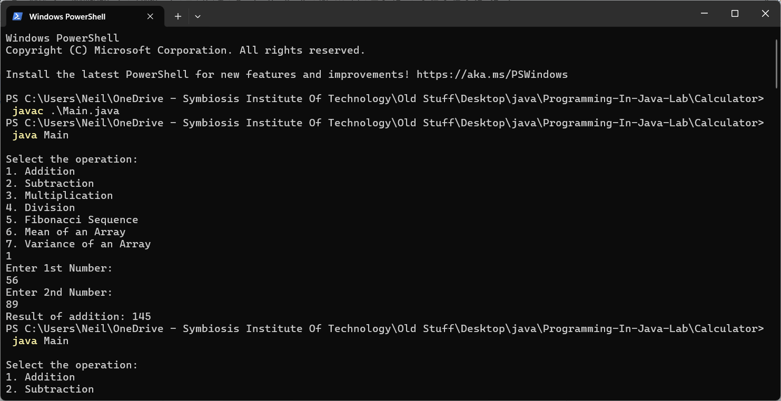

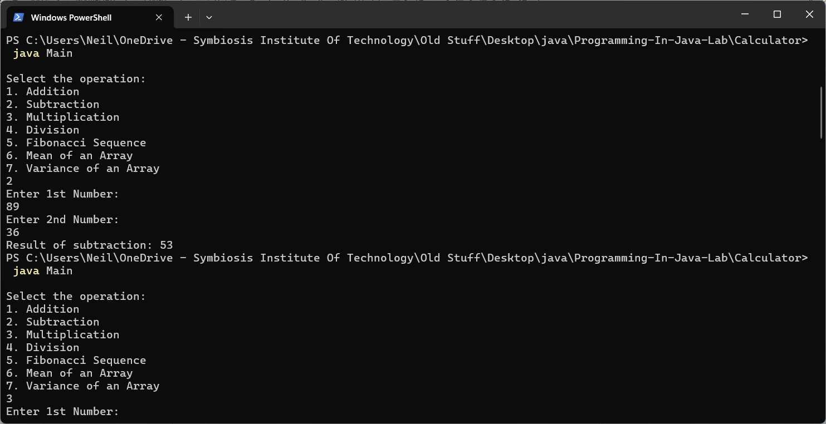

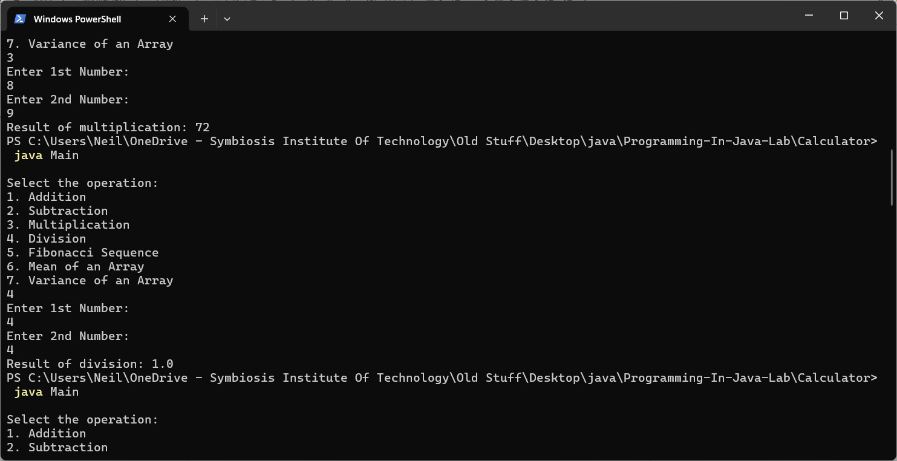

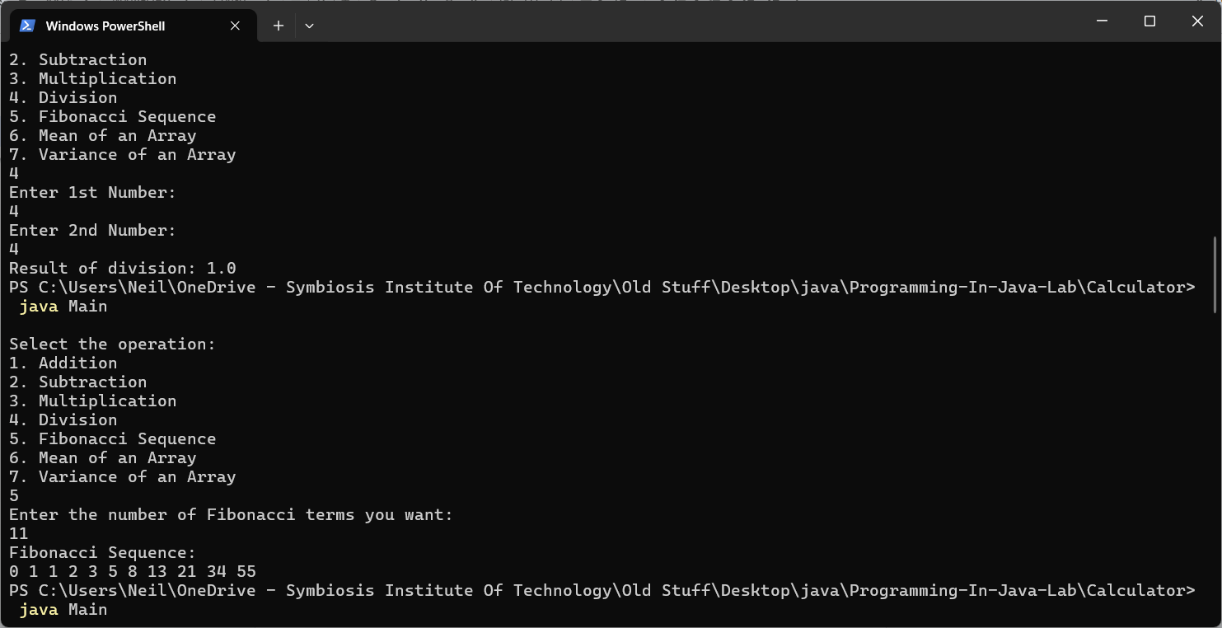

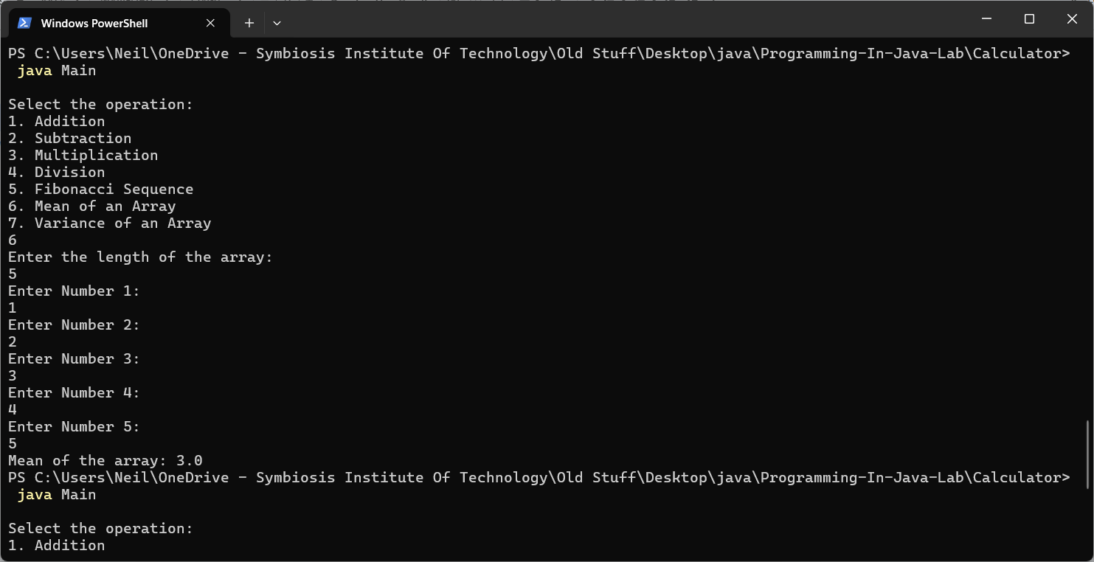

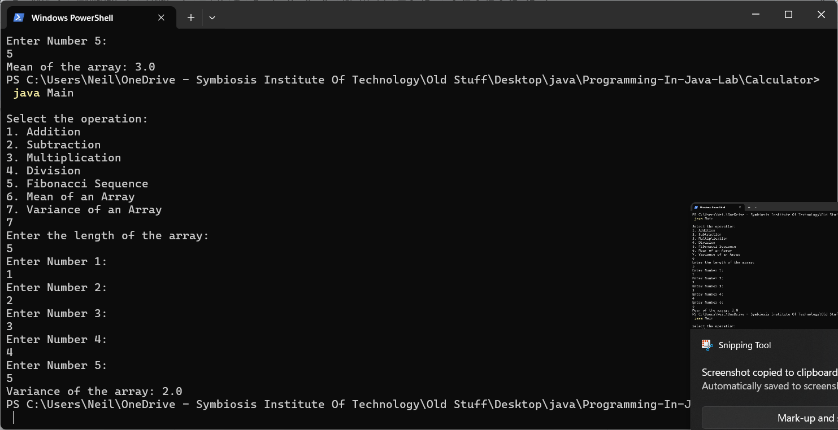

5. Calculator Repository

https://github.com/Neil-Cardoz/Programming-In-Java-Lab/tree/main/Calculator